**Finding the Features: Step length, Step width, Gait speed**

1. Extraction of gait coordinates using 3d pose repository. Coordinates are collected w.r.t. following scenarios:

**Person 1**

* 1. *Normal walk – 10 seconds*
  2. *Counting backwards 7 - 10 seconds*

***Person 2***

* 1. *Normal walk – 20 seconds*
  2. *Counting backwards 7 - 20 seconds*

1. The captured frames are in the form of arrays with 17 joint coordinates
2. There are three gait measures extracted in this work: **Step length, Step width** and **Gait speed**. *Note*: For the measures - *frequency and step time,* we need to get complete human coverage during walking and also frame rate needs to be computed. The package we are using is 3d-pose and it has limitation of covering only up to 3 meters. Hence, we proceeded only with mentioned 3 metrics.
3. **Step length** is calculated by finding the distance between, left foot and right foot and given by

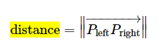

To compute the same, left foot is multiplied by the transpose of right foot and absolute value is taken

1. The corresponding code is given below

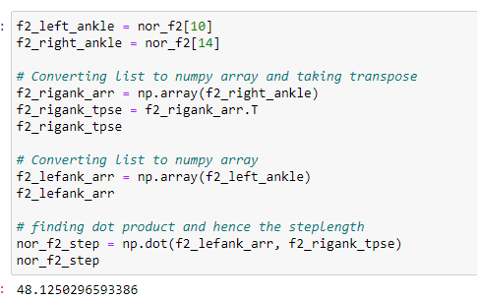

1. **Step width** is calculated by using the distance formula:



Where p and q are the joints of left and right foot respectively

1. The code for the same is given below

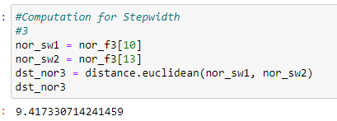

1. **Gait speed** is given by the formula



where **Cadence** is the number of steps taken in a minute.

In general, given by,

$Cadence= \frac{No of steps}{No of frames*no of secs/min}$

1. The code for the same is given below

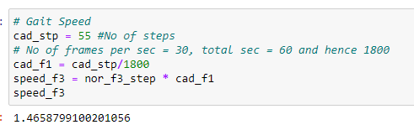

1. The calculation is computed for **Mean, standard deviation, minimum and maximum** values of the *gait measures*. The details are given below

**PERSON 1**

**Scenario #1: Normal walk - 10 seconds**

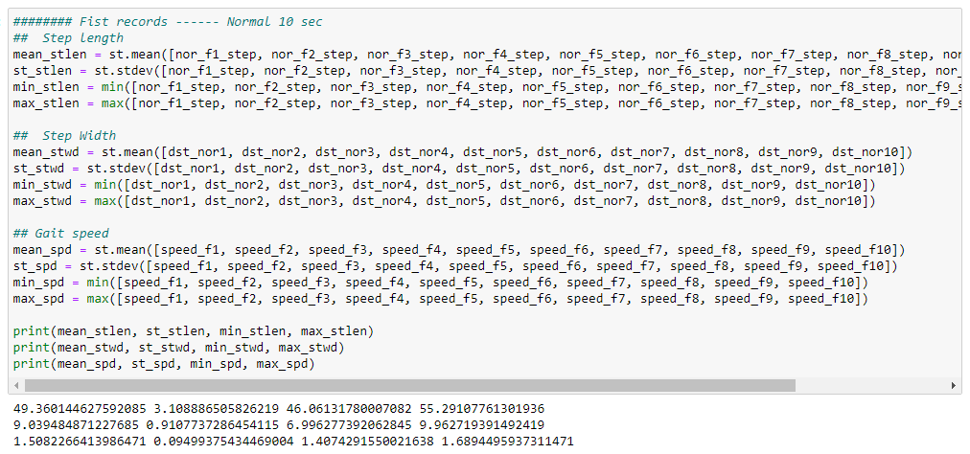

**Scenario #2: Counting back 7 - 10 seconds**

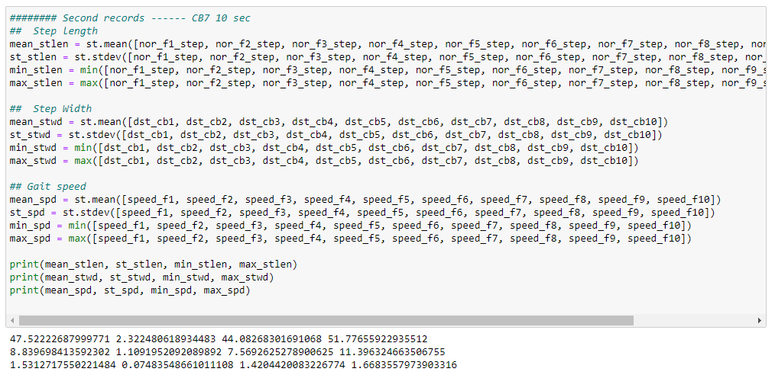

**PERSON 2**

**Scenario #3: Normal walk - 20 seconds**

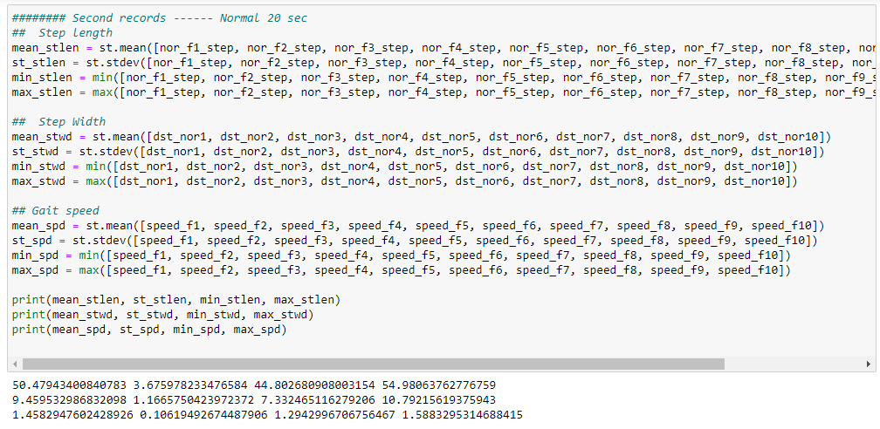

**Scenario #4: Counting back 7 - 20 seconds**

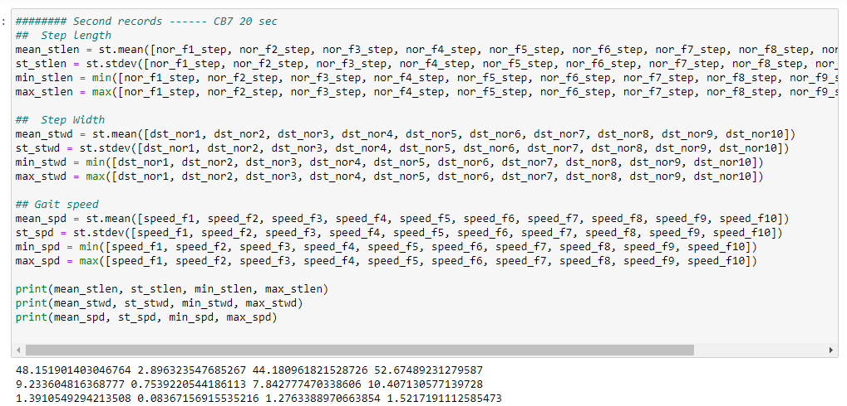

1. Data is organized as below. We are more concerned with mean and hence mean is taken for each of the measures

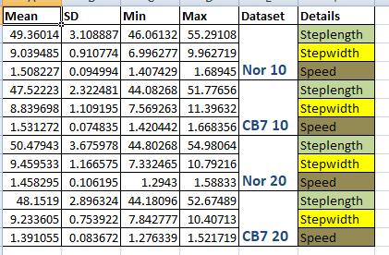

1. The test records are organized as follows

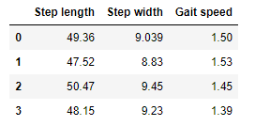

1. The test records are now evaluated with *JOE_Gang_K12_T1T2 dataset*
2. **Logistic Regression** and **Naive Bayes algorithms** are *used for evaluation*. Screenshots are below

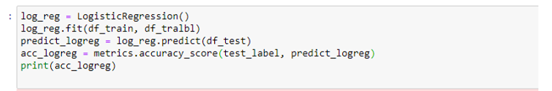

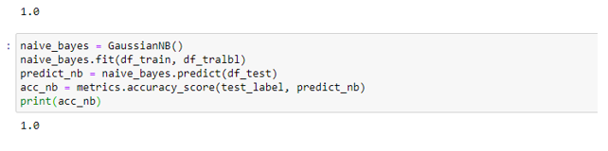

1. The accuracy obtained for the test records is 100%